Design Principles - Abstraction
# Source: AI Source: Provided by: [Data Path: Persons Table -> ID Column: 1, Name_En Column: Motasem Essam] -> From: [ChatGPT] on [1/23/2026]
Abstraction is the principle of hiding the complexity of a component or system while exposing only the essential features needed by others.
👉 Think of it as a TV remote: you press buttons without knowing the electronics inside.

🔑 Key Points
# Source: AI Source: Provided by: [Data Path: Persons Table -> ID Column: 1, Name_En Column: Motasem Essam] -> From: [ChatGPT] on [1/23/2026]
- Focus on what a component does, not how it does it
- Reduces coupling between components
- Makes systems easier to understand, maintain, and extend
- Supports flexibility, allowing multiple implementations behind the same interface

❌ Bad Example
# Source: AI Source: Provided by: [Data Path: Persons Table -> ID Column: 1, Name_En Column: Motasem Essam] -> From: [ChatGPT] on [1/23/2026]
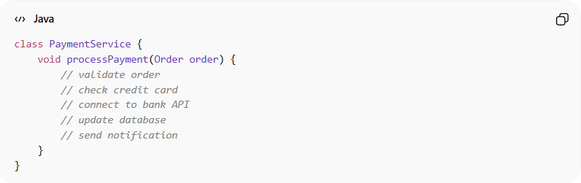
class PaymentService {
void processPayment(Order order) {
// validate order
// check credit card
// connect to bank API
// update database
// send notification
}
}
Problems:
- Exposes too much internal detail
- Users of the service need to know internal workings
- Hard to swap or extend functionality

✅ Good Example
# Source: AI Source: Provided by: [Data Path: Persons Table -> ID Column: 1, Name_En Column: Motasem Essam] -> From: [ChatGPT] on [1/23/2026]
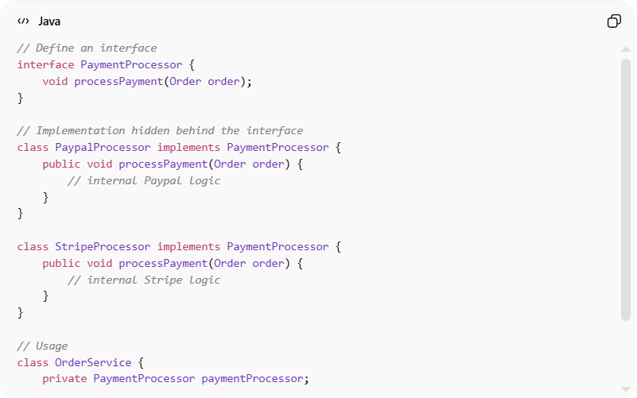
// Define an interface
interface PaymentProcessor {
void processPayment(Order order);
}

// Implementation hidden behind the interface
class PaypalProcessor implements PaymentProcessor {
public void processPayment(Order order) {
// internal Paypal logic
}
}

class StripeProcessor implements PaymentProcessor {
public void processPayment(Order order) {
// internal Stripe logic
}
}

// Usage
class OrderService {
private PaymentProcessor paymentProcessor;

void pay(Order order) {
paymentProcessor.processPayment(order); // ✅ no internal details exposed
}
}
Benefits:
- Users of PaymentProcessor don’t need to know implementation details
- Supports multiple interchangeable implementations
- Promotes flexibility and maintainability
- Reduces dependencies and coupling

⚡ When to Apply
# Source: AI Source: Provided by: [Data Path: Persons Table -> ID Column: 1, Name_En Column: Motasem Essam] -> From: [ChatGPT] on [1/23/2026]
- Whenever a module’s internal implementation may change over time
- For APIs, libraries, and services
- Combine with encapsulation to protect internal state and provide clean interfaces

